**CIS 362 Project 1**

**Shower Survey - Phase 3**

**March 16, 2020**

**Team 9 -** Jehu Barbee, Eric Botelho, Ashley Famularo, Grady Landers, Michael Medeiros

**Introduction**

Our group was tasked with the creation of a survey revolving around the showering habits of the students of the university of Massachusetts Dartmouth. The university was spending a lot of money on the pumping and recycling of water on campus, primarily from the resident halls. The university wanted to figure out a way to reduce the amount of money spent, one way of which is by developing a shower app for the residents to use as a way to monitor their shower times. Colorado University has done a similar, but more wide scale research on the water usage across the whole campus. While this research involved more factors than ours it still had a similar goal of reducing the amount of water used on campus. Their approach to this phenomenon is much different than ours as they had plans to upgrade equipment and educate students and faculty about the climate around the campus and how to conserve water even while off campus. As students, we do not have the means to do as Colorado University has planned, but we do have the ability to make our students aware of how much water they are using and also ways to keep track of how long they are showering for. While the way we went about our research was different from one another, our broad goal of reducing water usage on campus is the same. A survey was sent out to students asking questions about themselves and their showering habits in order to get a good baseline for how much water students use on campus. With this information, we were able to generate graphs that display the data, making it easier to understand trends in order to find effective ways to get students to reduce their water consumption.

**Hypothesis**

Freshmen and sophomores who live on campus will take shorter showers because they share community bathrooms/showers but juniors and seniors will take longer showers as they have private bathrooms.

**Visualizations**

|  |  |  |  |  |  |  |  |  |
| --- | --- | --- | --- | --- | --- | --- | --- | --- |
| **Attribute** | **Mean** | **Median** | **Std Dev** | **Variance** | **Range** | **Skew** | **Quartiles** | **Outliers** |
| Gender | 0.516 | 1 | 0.5 | 0.25 | 1 | N/A | N/A | N/A |
| Age | 21.112 | 20 | 5.822 | 33.896 | 51 | 6.14 | Q1: 19  Q2: 20  Q3: 21 | 69 |
| School Year | 2.227 | 2 | 0.936 | 0.876 | 4 | 0.071 | Q1: 1  Q2: 2  Q3: 3 | N/A |
| Resident | 0.51 | 1 | 0.5 | 0.25 | 1 | -.041 | Q1: 0  Q2: 1  Q3: 1 | N/A |
| Gym/Sports | 0.459 | 0 | 0.498 | 0.248 | 1 | 0.164 | Q1: 0  Q2: 0  Q3: 1 | N/A |
| Shower other places | 0.082 | 0 | 0.274 | 0.075 | 1 | 3.056 | Q1: 0  Q2: 0  Q3: 0 | 1, 1, 1, 1, 1, 1, 1, 1 |
| Avg. Showers per week | 6.612 | 7 | 2.735 | 7.482 | 16 | 1.034 | Q1: 5  Q2: 7  Q3: 7 | 15, 17 |
| Avg. Shower time | 16.031 | 15 | 9.238 | 85.336 | 58 | 1.739 | Q1: 10  Q2: 15  Q3: 20 | 60, 45 |
| Occasionally longer | 0.847 | 1 | 0.36 | 0.13 | 1 | -1.927 | Q1: 1  Q2: 1  Q3: 1 | N/A |
| Can reduce | 0.827 | 1 | 0.379 | 0.143 | 1 | -1.725 | Q1: 1  Q2: 1  Q3: 1 | N/A |

**Gender**

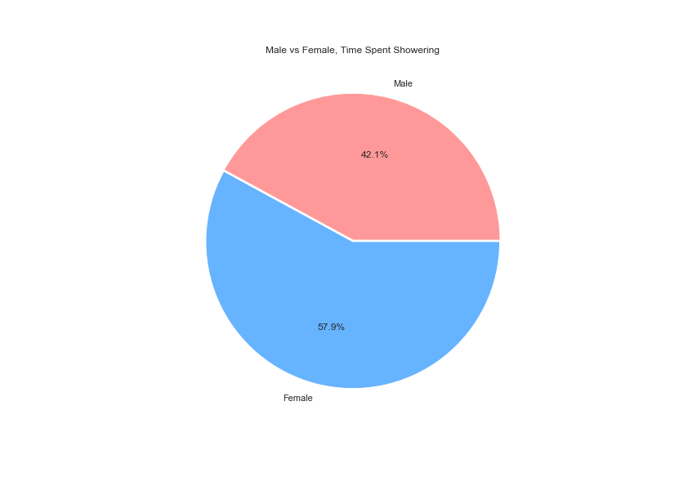

The values for gender were coded in such a way that 0 represents female, 1 represents male, and 4 people chose not to answer which is why skewness and quartiles could not be calculated. The mean value is 0.516, which in this case means 51.6% of the focus group identified as male. The median value is 1, which indicates that the value in the center of the data is 1, supporting that 51.6% of the sample space is male. The standard deviation and variance are 0.5 and 0.25 respectively, which are low to be expected because the only values are 0 and 1, which explains the range of 1. The pie chart above shows the total length of showers, based on average shower time collected, grouped by the gender of the person. Given that the percentage of individuals identifying as female was calculated to be 51.6%, the fact that 57.9% of time showering is taken up by those people would seem to indicate that females tend to take longer showers than males.

**Age**

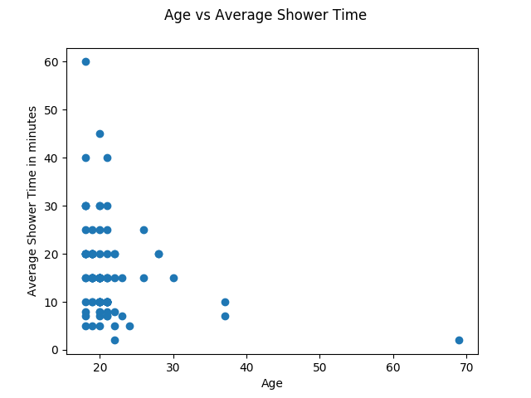

The mean value for age is 21.112 years old which indicates that the majority of the focus group were around 21 years of age. The median is 20 years old, expectedly close to the mean. The standard deviation and variance are 5.822 and 33.896 respectively, relatively low showing that in general the ages were not too far off from each other. The skewness is 6.14, somewhat high but can be explained by the outlier of 69, the max for this data that results in a range of 51. The first, second and third quartiles are 19, 20, and 21, meaning that the first 25% of students are 19 or younger, 50% are 20 or older, and the top 25% are older than 21, supporting the mean age of 21. Above is a scatter plot comparing age and average shower time for each data point. From this visualization it can be seen that the correlation between age and average shower time is negative, meaning older participants in our survey showered for less time, on average, than younger ones.

**School Year**

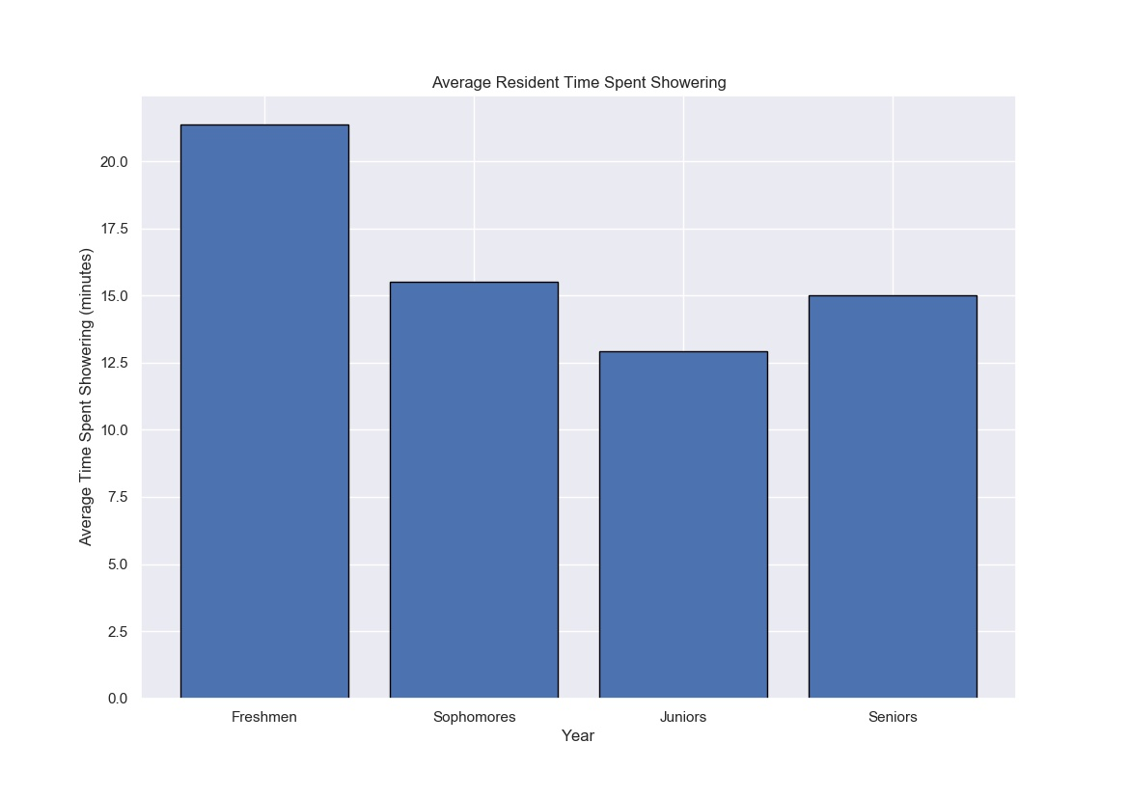

School year was coded from 1 to 5, 1 being freshman and 5 being any graduate student over 4 years into school. The mean value is 2.224 and median is 2, indicating that most of our focus group are sophomores. The standard deviation and variance are 0.936 and 0.868 respectively, reasonably low considering the data was coded to have a range of 4, which also explains the low skewness of 0.071. The first, second and third quartiles are 1, 20, and 3, meaning that the first 25% of students are freshman, 50% are sophomores, and the top 25% are juniors or higher. Expectedly there are no outliers for this attribute. Above is a bar chart showing how average shower time varied across the given year of the student. Based on this visualization of the data, Freshmen take the longest showers, an average of just over 20 minutes at a time, Juniors take the shortest showers, around 12.5 minutes, and Sophomores and Seniors are in the middle with their average shower time each around 15 minutes.

**Resident Status**

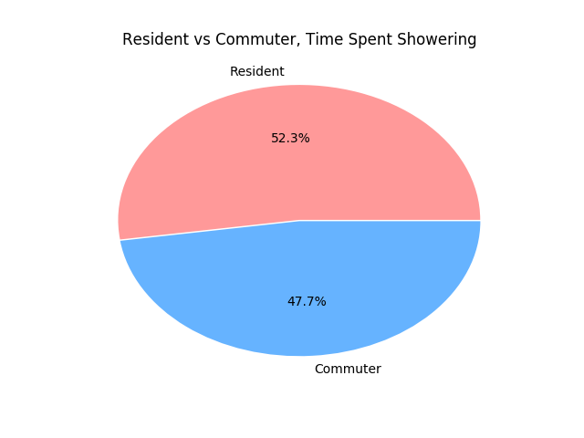

Resident status was coded with a value of 1 for residents and 0 for commuters. The mean value is 0.51 which in this case implies that 51% of the focus group are resident students, supported by the median value of 1. The standard deviation and variance are 0.5 and 0.25 respectively, which are low to be expected because the only values are 0 and 1, which explains the range of 1. The skewness is -0.041, very low suggesting a tight data set. Expectedly there are no outliers for this attribute and the quartiles are not worth mentioning. Above is a pie chart showing the break up of total time showering between resident students and commuters. The computed ratio found that 51% of participants are residents, therefore this representation is fairly accurate in displaying that commuters spend a little less time showering than resident students.

**Extracurricular**

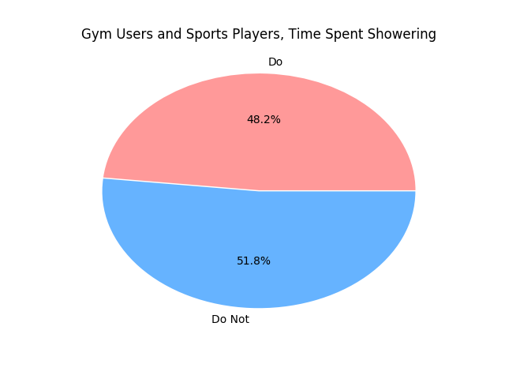

Based on the statistical analysis of whether students use the gym or play a sport, 45.9% said they do, given the mean of 0.459 and median of 0. This measure was also coded with a 1 for yes and 0 for no, so the standard deviation of 0.495, variance of 0.248 and range of 1 are expected. The skewness is 0.164, very low suggesting a tight data set. Not surprisingly there are no outliers for this attribute and the quartiles are not worth mentioning. The pie chart above compares the amount of time spent showering by gym users and sports players to those who do not use the gym or play a sport. Based on this chart and the fact that about half of the participants answered that they do participate in these forms of exercise, those students that do use the gym or play a sport shower for slightly less time than those students that do not.

**Showering Location**

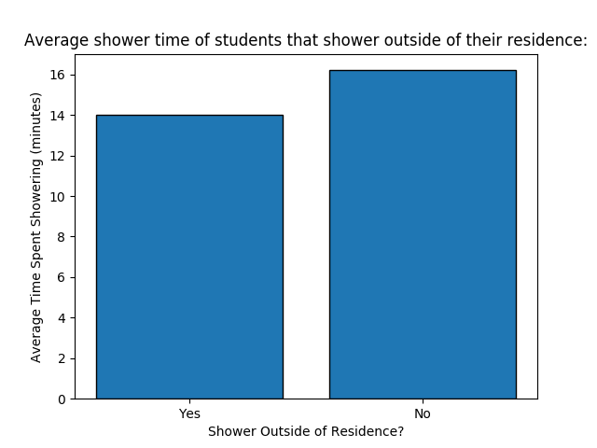

Based on the statistical analysis of whether students shower anywhere other than their place of residence, only 8.2% said they do, given the mean of 0.082 and median of 0. This measure was also coded with a 1 for yes and 0 for no, the standard deviation and variance are 0.274 and 0.075 respectively, so low due to how few values are not 0, also explaining the relatively high skewness of 3.056. The quartiles are all 0, supporting how the only values above 0 are in the top 25% of the data, therefore the outliers for this data were the cases where students replied yes. The bar chart above compares the average shower times of students that only shower in their dorms or house and those that might shower elsewhere as well. This visualization shows that students who do shower in multiple places have a reduced average shower time, implying that they might be more conscious of conserving water.

**Average Showers per Week**

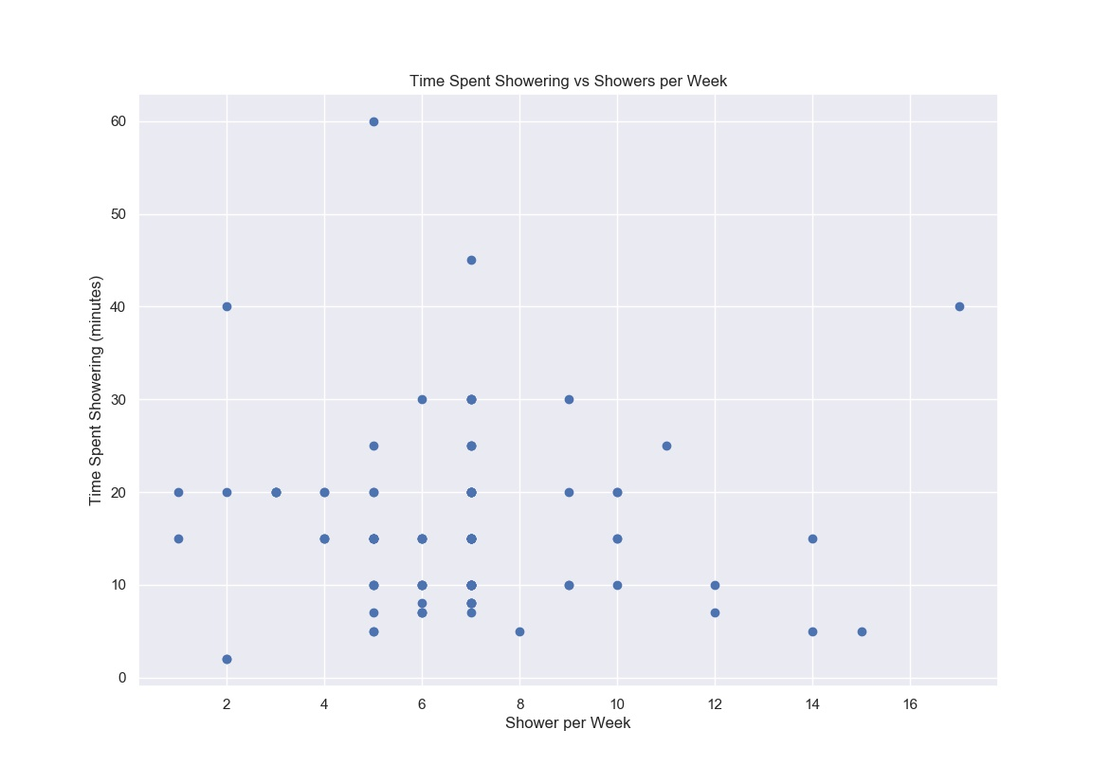

Based on the statistical analysis of the students average showers per week, the average amount of showers that students at UMass Dartmouth take is 6.612 given the mean. With a median value of 7 that indicates the data points are centered around that value and with a standard deviation of only 2.735 it is fair to say that the average shower time is fairly close to the median value. There were two outliers of 15 and 17 showers per week, which explains why there was a high range of 16. The two outliers are also a cause of the slight positive skewness of 1.034 as the data is centered around the median of 7 so there is an ever so slight trailing tail towards the right. The quartiles in order are 5, 7, and 7. This data shows that 75% of students surveyed take 7 showers or fewer a week and only the bottom 25% take 5 or less. That leaves the top 25% taking more than 7 showers per week. The scatter plot for this attribute compares average shower time and average showers per week for each data point. From this plot the correlation can be derived, which appears to be negative. A negative correlation between average showers per week and average shower time per person makes sense because one would reason that someone who showers more often does not need to for as long each time and someone who showers only a few times a week should spend more time getting clean. Using the calculated mean and standard deviation we were able to come up with intervals for 87 and 97 percent confidence. Given our data we are 87% confident that the average number of showers taken per week by UMass Dartmouth Students is between 6.1937 and 7.0303, and 97% confident that it is between 6.0125 and 7.2115.

**Average Shower Time**

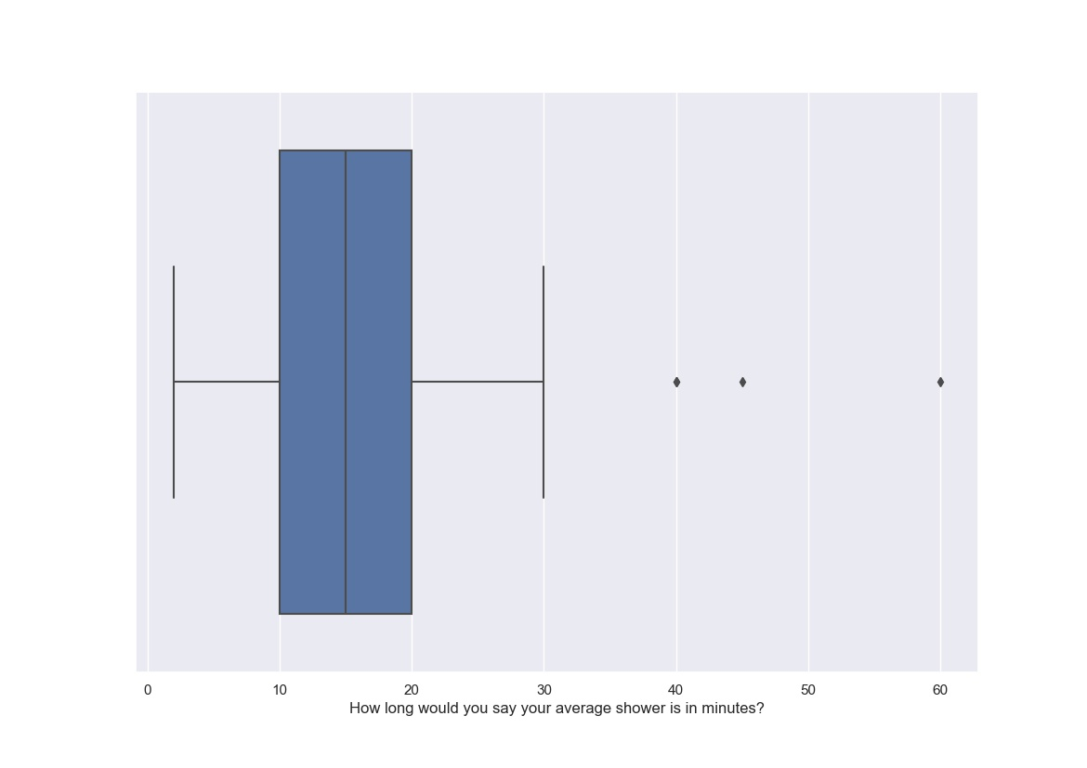

Based on the statistical analysis of the average time spent showering of UMass Dartmouth students, the average shower took 16.031 minutes. The data centers around the median of 15 but with a high standard deviation of 9.238, there can be a point made that the data points are actually not too closely centered around the mean. Although what may be contributing to the high standard deviation is the large range of 58 caused by two outliers of 45 and 60 minutes. Once again there is a positive skewness of 1.739 which is most likely caused by those two outliers which have caused a slight trailing tail towards the right with most of the data points on the left. The first quartile for this attribute is 10, expressing that the bottom 25% of the population take a shower of 10 minutes or less, the second quartile is 15, therefore 50% take a shower of 15 minutes or less, and the third quartile is 20, representing how only the top 25% of students surveyed take showers of 20 minutes or more. Above is a boxplot of the data collected for average shower time. From this representation it is clear that most of the data lies in the range of 3 to 30 minutes and a majority between 10 and 20 minutes, making the responses of 40, 45, and 60 minutes each outliers. Using the calculated mean and standard deviation we were able to come up with intervals for 87 and 97 percent confidence. Given our data we are 87% confident that the average length of showers by UMass Dartmouth Students is between 14.618 and 17.444, and 97% confident that it is between 14.006 and 18.056.

**Longer Showers**

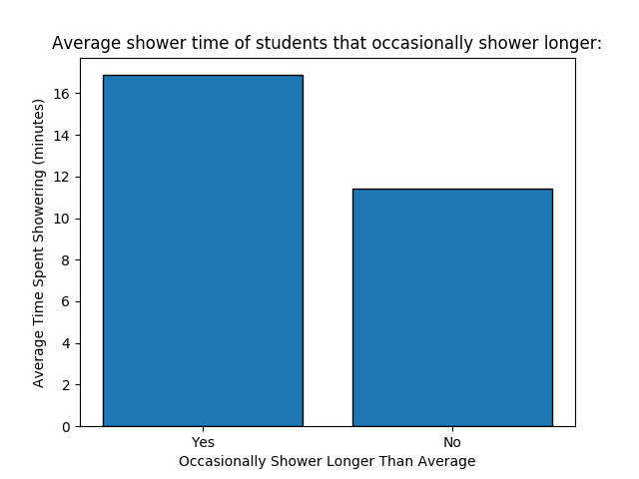

One question that was asked was if UMass Dartmouth Students sometimes take longer showers than what they normally do. The responses were coded such that 0 represented that they do not take longer showers than normal and 1 represented that they do. 84.7% of the people surveyed said they do sometimes take longer showers than normal as indicated by the mean of 0.847. The median value supports this as most of the data points were centered around 1. With an expected low standard deviation of 0.36 and a variance of 0.13 as the only possible responses of 0 and 1 this explains the range of 1. The skewness of -1.927 reflects how most of the focus group answered that they did occasionally take longer showers. The quartiles are all 1, showing how only in the bottom 25% of responses did people answer that they never take longer than average showers. Expectedly, there are no outliers for this data. Above is a bar chart comparing the average shower time of those students who identified as occasionally taking longer showers to those who said they never do. From this chart it is clear that students who never take longer than average showers take shorter showers overall as well, suggesting that they are either forced to take relatively short showers or are conscious about conserving water.

**Willingness To Reduce Shower Time**

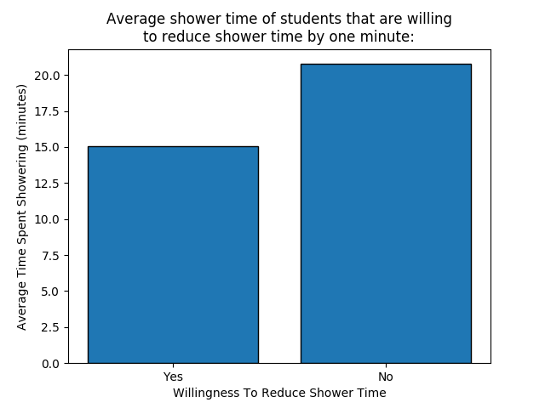

Another broad question we asked was whether students believed they could reduce the time of each of their showers by one minute. This question was also coded with 0 as a negative response and 1 as a positive response. The mean calculated is 0.827, representing that 82.7% of the focus group believes they can shorten the length of their average shower. The median for this attribute is 1, supporting how the data is centered around a positive response to the question. Standard deviation and variance are 0.379 and 0.143, low as a result of the range being only 1. The skewness of -1.725 is consistent with the fact that a majority of the focus group answered that they believe they can reduce the time they spend in the shower by at least one minute. The quartiles are all 1, showing how only in the bottom 25% of responses did people answer negatively, and there are no outliers. This data is visualized by the above bar chart comparing average shower time of those students who think they can reduce their average shower time and those that said they would not. Surprisingly, the students that replied positively reported shorter average shower times, suggesting students who take longer showers on average, the ones we would like to target the most, are least likely to cooperate in conserving water.

**Correlation**

|  |  |
| --- | --- |
| Age vs Average Shower Time: | -0.230966 |
| School Year vs Average Shower Time: | -0.258084 |
| Resident Status vs Average Shower Time: | 0.045231 |
| Extracurricular vs Average Shower Time: | 0.081178 |
| Showering Location vs Average Shower Time: | -0.065537 |
| Showers Per Week vs Average Shower Time: | -0.011645 |
| Occasionally Longer Showers vs Average Shower Time: | 0.213098 |

Based on the correlations calculated, some relationships between the general attributes and shower times in minutes can be made. Age and school year have relatively high magnitude, negative correlations with average shower time, suggesting that older students tend to take shorter showers. When looking at whether students acknowledge occasionally longer showers, the correlation to average shower time is relatively high and positive, suggesting that those students tend to also take longer showers over all. Less significant outcomes show positive correlations with resident students and those who exercise or play a sport. Lastly, the number of showers per week and whether students shower anywhere other than their residence seem to have negative correlations with average shower time.

**Analysis and conclusion**

Looking over the questions in our survey there is a bias that tends to lean toward residents rather than commuters as most of the questions focus around students that live on campus and use the resources provided, such as the gym. Though the topic of the survey is water usage on campus so the topic itself is naturally biased towards those that are on campus all the time. While the question that our group decided to include the final version of the survey cover a broad spectrum of variables that would affect how many showers a single student might take in a week, there are definitely many more factors and variables that could affect how many and how long an individual's showers are, we could make a valid conclusion based off the information we collected. The results that we collected will be passed off to students in senior design to develop a shower app that will track the shower time of the individual and will help them develop better habits to shorten their shower times to reduce the total amount of money the college is spending on pumping and disposing of water on campus.

With regards to the hypothesis the findings in the bar graph of the average shower times of each class it is fairly easy to say that our hypothesis was disproved. With the freshman class actually taking the longest showers and the sophomore class having just over 15 minutes of average showering time, they actually took longer showers than the juniors and seniors. This may be because freshmen and sophomores don’t know as many people on campus and are trying to make a good impression by not smelling bad. Also with community bathrooms, they may bring their clothes with them into the shower stall so they might have considered the time to change in the stall with their actual shower time. Juniors and Seniors took the shorter showers, and that may be because they have more things they need to do or are also more comfortable with themselves and not feel the need to take excessively long showers.

**References**

Colorado University Water usage:

<https://www.colorado.edu/ecenter/sites/default/files/attached-files/campus_water_use.pdf>